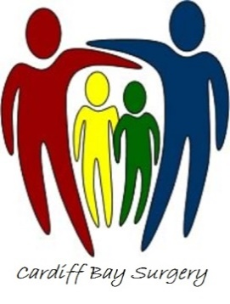

Cardiff Bay Surgery Cardiff Bay Surgery
45 Cambridge Street Plas Iona
Grangetown Butetown
Cardiff Cardiff
CF117DJ CF10 5HW
Tel:02920099378 Tel :02920099378

Our Practice list is open to people who live in the Grangetown, Riverside, Butetown, Cardiff Bay and Cardiff City Centre areas.
Please ring the Surgery or call into reception when the Surgery is open to enquire about registration if you are unsure.
In accordance with Health Board recommendations, all new patients should present two forms of identification, which proves residency and authenticates their identity. This is required to reduce and prevent fraudulent attempts to obtain or misuse NHS care.
All new patients will have to complete a Registration Form, which can be downloaded from our website
Overseas visitors may be asked for additional information to prove NHS entitlement.
One form of identity must ideally be photographic such as:
Passport
Drivers Licence
Official ID card from Public Services body
Student matriculation card (current year)
Other documents for prove of residency that are acceptable are:
Recent utility bill (within last 3 months)
Council Tax document
Television Licence
Payslips (last two months)
Rent book/agreement (Public Body or Private Landlord)
Bank Statement (Name and address section only required)
Solicitors Letter- (Clearly showing name and address)
If unable to provide photographic evidence then you must present one of the above and one of the following:-
Birth Certificate
Marriage/Civil Partnership Certificate
Divorce/Annulment Papers.
N.B. The above list is not exhaustive and staff are entitled to ask for further proof if required. Please note you will not be registered with the practice if you cannot provide the documents required to prove NHS eligibility. If you have been previously registered at another doctors surgery
Please note that these documents should be bought to the practice in person along with the completed registration form for identity verification and to ensure all paperwork is completed in a proper manner.
Thank you,

Cardiff Bay Surgery Admin team

